***Assignment Name****:* ***Lab1:*** *(****Syntax & Logical Errors)***

***Due date:******9/14/2022, by 11:00 am.***

***Grade for assignment: 10*** *points*

***Purpose:*** *Obtain experience in locating and correcting coding errors and realizing the importance of security in software development. Assignment accomplishes course learning objective “analyze problems and design structured solutions”. Assignment also provides preparation for COSC236 course, and enhances skills needed in Information Technology (IT) and Computer Science industries.*

***Skills:*** *Purpose of assignment is to help you practice the following skills.*

*-Recognize and avoid syntax errors and Logical errors*

*-Ability to debug and test a computer program*

***Knowledge:*** *Become familiar with working in an Integrated Development Environments (IDE), (i.e. Visual Studio CODE) when developing, testing and debugging computer code.*

***\*\*\*\*\*\*\*\*\*\*\*\*\*\*\*\*\*\*\*\*\*\*\*\*\*\*\*\*\*\*\*\*\*\*\*\*\*\*\*\*\*\*\*\*\*\*\*\*\*\*\*\*\*\*\*\*\*\*\*\*\*\*\*\*\*\*\*\*\*\*\*\*\*\*\*\****

***Place your Name(s) below:***

***Pairs work:*** *Please work in pairs.* ***One student in team should submit work****. Put* ***your first and last name on the assignment*** *and* ***your partner’s first and last name on the*** *assignment*

***Note(s):***

1. *All programs should be completed within the Visual Studio Code environment. There are guides in blackboard to start you off with Visual Studio Code.*

***Partner 1: Name*** Blessing Abumere

***role (did the typing or read and review) _____________________________***

***Partner 2: Name ______________________________________________***

***role (did the typing or read and review)______________________________***

***Please note if one partner did not work on all problems.***

***Submission instructions:*** *All submissions will be done using blackboard.* ***Answers are to be submitted in a Microsoft word document.***

***Task****:*

***Examples:*** *Refer to your notes from class, the Introduction PowerPoint, the C++ Information PowerPoint, and any available videos (all located in Blackboard).*

***Part1 (5 points):***

1. *Type in the following program. Add a comment at the top to include your name(s) and the date.*

*#include <iostream>*

*using namespace std;*

*int main()*

*{*

float num1;

*float num2*

*float avg;*

*cout << "Enter two numbers" << endl;*

*cin >> num1 >> num2;*

*avg = num1 + num2/2;*

*cout << "The average is " << avg;*

*return 0;*

*}*

1. *Try to compile. There should be a* ***syntax error****. The compiler should give some indication of where the error occurred. Attempt to correct the error and compile again.*
   * float num2 doesn’t not have a semicolon
2. *Run the program several times, entering different values. Examine the output carefully. Is it what you expect? There should be a* ***logic error****, or a bug. See if you can correct it.*
3. *Test your program to make sure it functions as you expect.*
4. ***SUBMIT your corrected code, and sample of output (Below):***

***Answer the following Lab Questions****:*

1. *What is the role of the compiler?*
2. *What was the syntax error in the above program?*
3. *What was the logic error in the above program?*

***Part2 (5 points):***

1. *Copy and paste the link below into a Google web browser and complete the Security Injection.* [*http://cis1.towson.edu/~cyber4all/modules/nanomodules/Software_Development_Lifecycle-CS0_C++.html*](http://cis1.towson.edu/~cyber4all/modules/nanomodules/Software_Development_Lifecycle-CS0_C++.html)
2. ***SUBMIT copy of Security Injection certificate(s) (Below):***

***\*\*\*\*\*\*\*\*\*\*\*\*\*\*\*\*\*\*\*\*\*\*\*\*\*\*\*\*\*\*\*\*\*\*\*\*\*\*\*\*\*\*\*\*\*\*\*\*\*\*\*\*\*\*\*\*\*\*\*\*\*\*\*\*\*\*\*\*\*\*\*\*\*\*\*\*\****

***Criteria for Success****:*

***a****) Be sure to submit your code and output above for each question;* ***Submission of Code and output is required****. (Note: use screen shots or copy and paste).*

*For example if the assignment was to write a program that displays “Hello World”*

*Your* ***code*** *would be as follows:*

*//Lab1 answer COSC175002*

*#include <iostream>*

*using namespace std;*

*int main()*

*{*

*cout << "Hello, world" << endl;*

*system("pause");*

*} // end of main*

*Your* ***output*** *would be as follows:*

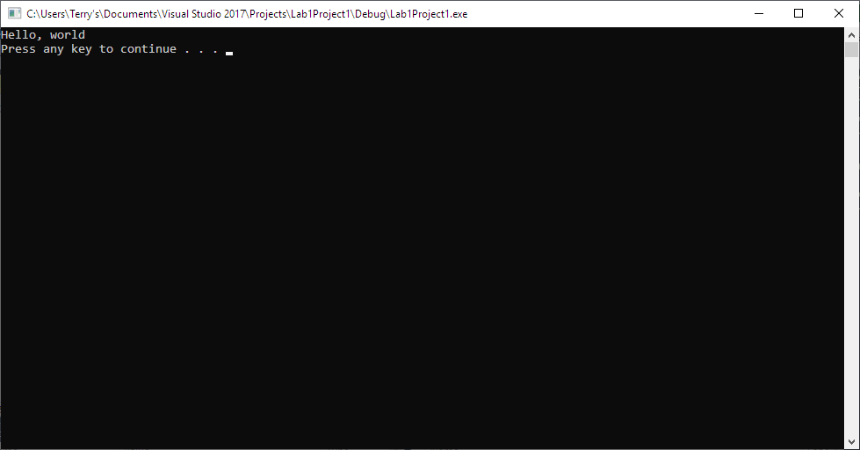

*Note: To avoid additional point deductions; remember to submit both code and output.*

*>>>*

***b)*** *Be sure to show completion of Security Injections by providing Screen shots of (or copy and paste) your Security Injection completion* ***Certificate*** *above****. Do not email me your certificate.***

***c) Late policy:*** *Late submissions will receive a zero grade. Get help during the week so that you can submit on time.*